This VI is a CGPA calculator which fully uses dialog boxes for its operation.

And another VI which sorts the marks in the excel file which is created by CGPA calculator VI.

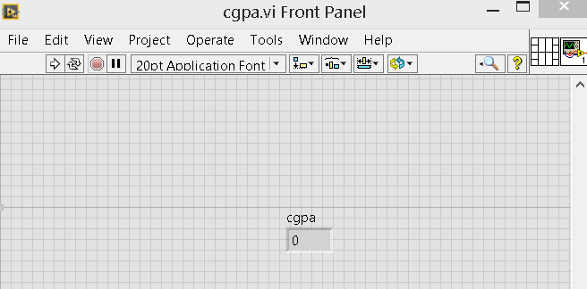

Front panel have only one indicator (cgpa)

After running the VI the below window pops up

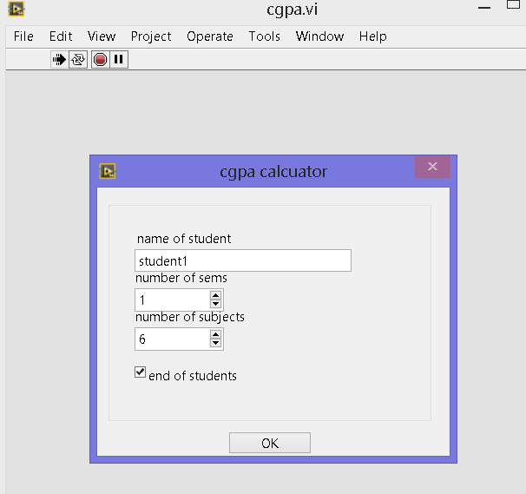

Name, number of semesters and students have been entered.

As I’m entering only one students mark, I checked “end of student’s checkbox”

After clicking “ok” the below window pop ups.

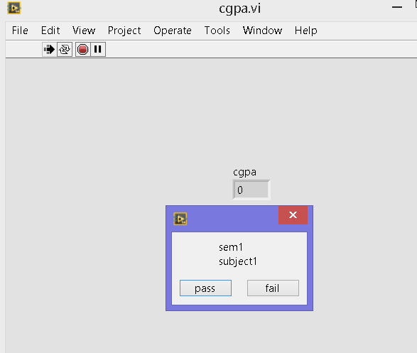

I have entered sem1-subject1 result as “fail”.

The next window pop ups.

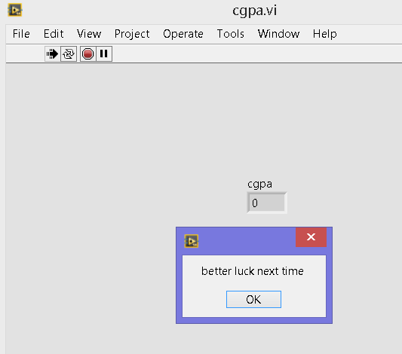

After clicking “ok button” VI asks for the result of next subject.

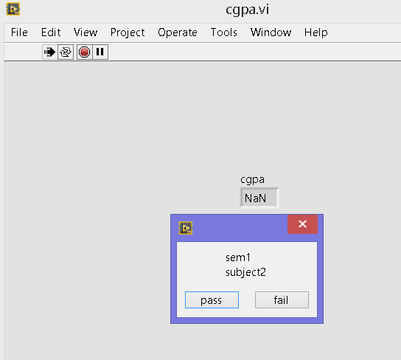

Now I click pass. Then the next window opens

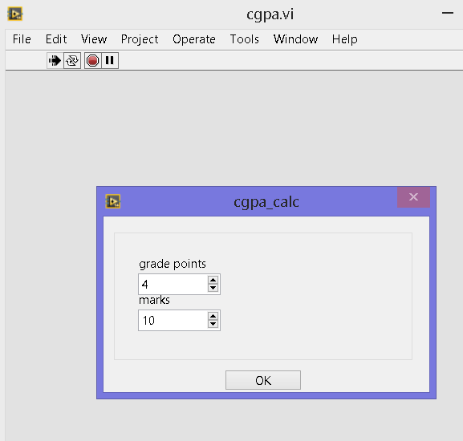

Now I enter corresponding grade points and marks of the subject.

Then press ok.

Likewise I have entered all the marks corresponding to a 10 CGPA

Finally CGPA is displayed in the indiacator

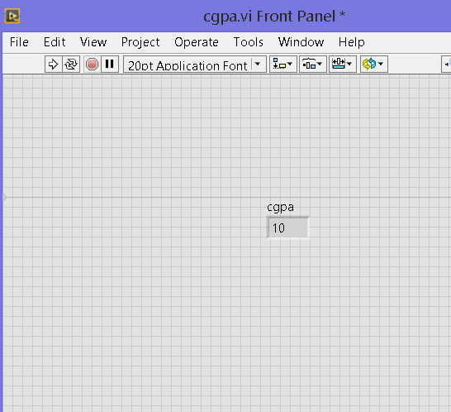

Name of the student , his cgpa are stored in an excel file given in the location below.

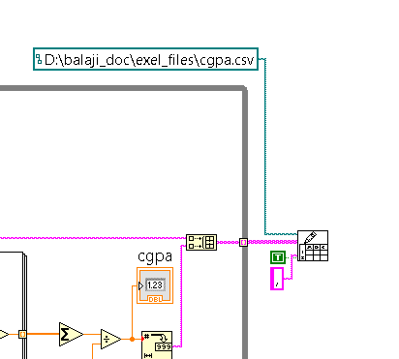

If we open the excel file then it looks like below.

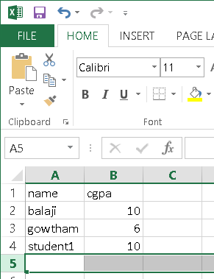

I have previously saved the file format with the marks of two people.

Finally cgpa sorter is runed to get the top score in the group. Result is shown as below.

